Fraaz Kagzi

Candidate no: Centre no:

Clitheroe Royal Grammar Sixth Form

A-level Coursework: Project Thesius

Contents

**ANALYSIS** 2

**Background to the problem** 2

**Pre - Development Interview with Douy Singsamaran** 2

**Potential Ideas and Chosen Idea** 3

***Description* of My Game** 4

**Features I could add** 4

**Users and Limitations** 4

**Research** 5

**References** 5

**An Existing game** 6

**What I want my game to look like** 7

**Data Flow Diagram** 8

**My Objectives for the Game** 9

**DESIGN** 10

**Screen transitions** 10

**Maze Generator Plan** 12

**Explaining Maze Generator** 15

**Maze Generator- Table of methods and Variables** 19

**Maze Generator - table of parameters** 20

**Enemy AI plan** 21

**Testing** 22

**Menu Testing Table** 22

**Player Movement Testing Table** 22

**Maze Generator Testing Table** 24

**Game Testing Table** 25

**Enemy Testing Table** 26

**High Score Testing Table** 27

**Public Testing** 28

**Evaluation** 29

**Comparison with objectives** 29

**ANALYSIS**_______________________

Client: Douy Singsamaran; Portfolio- <https://singsamran.artstation.com/>

## **Background to the problem**

Douy is an artist, graduated from Kent university. Throughout the course of his degree he has made many art pieces and animations. He desires to enter the video game scene as an artist, however Douy is unsure whether his art style will be suitable for video games. In order to test the suitability for his art, he asked me to create a video game. If this test is successful, the game would be a great addition to his portfolio as an inspiring game artist. Although he did influence what the main frame of the game should be, I was given freedom to add features which I thought would make the game more interesting as well as challenging when it comes to implementing these ideas to a program.

## **Pre - Development Interview with Douy Singsamaran**

**Is there a certain type of game you would like to be made?**

DS: I don’t want the game to be very difficult. Something not too simple and not too complicated. Something that feels familiar like Pac-Man, but with a twist. I would like it to be endless, so like the game lasts as long as the player’s character is alive.

**You want this game to be heavily influenced by Pac-Man, but how would you like it to**

**differ?**

DS: Pac-Man’s main target is just to collect those points and survive. I would like the game to have this as the basis however, in addition to this, if possible it would be good to add some sort of weapon to fight off against enemies and give it some horror aspects.

**How will this game be useful for you?**

DS: For artists, your portfolio is the most significant thing when applying for a job in art. Specifically for me, as I want to hopefully become a game artist, most companies will look through my portfolio to see if I am a suitable candidate. This game will be able to showcase my art to companies and show how my art, whether it fits or not, looks when situated in a game. This would make my portfolio unique.

**You said you want to showcase your art; do you have an idea of how you want this to be done?**

DS: I’m going to create all the necessary assets for this game whether that be the characters and enemies or the backgrounds and resources. So, however the game is played, the player would always be able to see some form of my art. The characters and enemies should be the most eye-catching. It’ll be good if the game has some sort of story behind it, but apart from that, there isn’t a specific way I want the game to showcase my art.

## **Potential Ideas and Chosen Idea**

1. Project Lava

An endless side-scroller platform game, where the objective is to avoid falling. Collecting some sort of items (e.g.: coins) will determine the score. If the character touches the ground the game will end and a table of high scores will be displayed

* This project would have been too simple, and I believe it would have been difficult to think about how to implement high level skills in such a simple program
* This project would limit how much Douy’s art is shown, a side scroller would mean that only one side of the art would be shown
* Due to only one side being shown, a mutual agreement between me and the end user was that this project would not be effective enough for Douy in terms of the limited skills displayed whether it comes to programming or art

1. Project Playtime

An application consisting of 5 mini games such as: a simple platformer, an endless runner and others. I got this idea from Douy’s previous artwork. For his university project, he created 5 3D character models, which he based on children's games, like: the floor is lava, hide & seek, king of the hill and tag. I had the idea of basing my game around these 5 characters and give each character their own mini game.

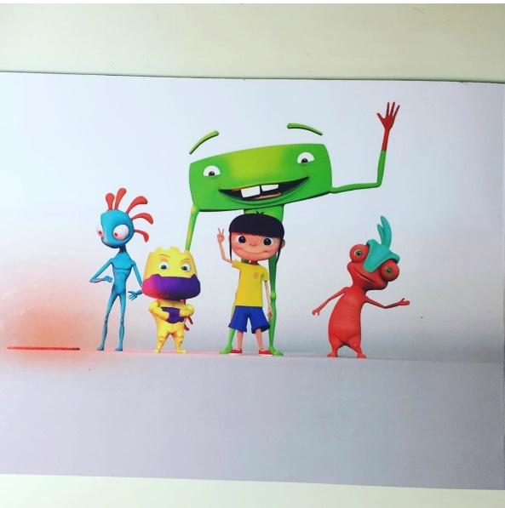

* This idea will require a lot of time, since I would be creating 5 separate games with different types of AI.
* Making this game very simple would make it suitable for the deadline, however doing this will decrease and minimize the high-level qualities my program could have.

1. [CHOSEN IDEA] Project Theseus

A survival maze game, heavily influenced by Pac-Man, where the objective is to find a certain number of keys and escape. This will be done whilst the player is getting tracked and chased down by monsters.

* This project would be difficult; however, I think it would be more manageable than Project Playtime
* This project has potential for me to implement many useful A-Level techniques as it has some features that make it fascinating to program

## **Description of My Game**

Project Theseus is a level-based survival game, where the player is trapped in a maze and has to find a certain number of keys, to unlock the door and escape. However, it is not that simple. Whilst the player is trying to find the keys, they are being hunted and chased down by monsters in the maze. To give this more of a horror theme, the maze will be quite dark.

I want this game to last as long as the player survives and not limit it to a certain number of levels. Therefore, I am going to make it so every level, the maze is going to be randomly generated which will make every level different. A personal feature I wanted to add, is to make every square in the maze accessible. Making the maze randomly generated, I am aware that there will be some squares that will not be accessible. I believe adding this feature would make the game more satisfying as well as being an opportunity to add some A-Level programming skills.

## **Features I could add**

Whilst the player is in the maze, he will have a flash light which is slowly deteriorating as the game is played. The battery level will determine the area covered by the light. There will be pickable battery cells which can increase the battery level.

The player would have 3 lives and every time in comes in contact with a monster they will lose a life. After all, lives are lost the game will end, displaying a table of high score consisting of players who made it the highest levels

## **Users and Limitations**

This game will primarily be used by Douy and also by companies viewing Douy’s art, who will be the main source of feedback. However, this game is not just limited to a certain number of users, as anyone with an interest for the game will be able to play it and become a secondary source of feedback. I am going to make this game available for alpha testing so I can gather as much feedback as possible, which will enable me to have a list of improvements needed.

Creating this game would not be simple, there are some definite limitations which restrict me for creating this game to be the best quality.

This is the first time I will be attempting to create a game so my knowledge would be a limitation. I will be spending a lot of time researching different algorithms, traversals and C# functions which would allow me to make my game closer to what I actually want it to be. I’ll be creating this game using unity which I have also never used before however unity allows me to program in C# which I have prior programming experience in. To boost my knowledge on unity and game developing, I am going to watch and follow many tutorials on making simple games on unity and gain knowledge on specific features such as implementing character movement.

Time will also be a major limitation since I only have till Easter to complete this whole project Which includes researching, documentation and the development of the project

## **Research**

**Most suitable software**

For the game, I had to decide which software to us to create the project. This was my first time creating a game so I did research on 2 game engines Unity and Unreal Engine. Unreal only allowed games to made with C++ or their own blueprints system which requires no programming. On the other hand, Unity allows games to made with C# which is the language I am most confident with, so I chose unity as the software I will be using to create my game.

**Player**

For the player, I needed to know how to make the character move. I watched many YouTube tutorials by professionals such as brackeys and learnt different ways this can be done.

<https://youtu.be/Au8oX5pu5u4> *- Brackeys - “How to make a video game in unity – MOVEMENT”*

<https://youtu.be/S2mK6KFdv0I> *- Brackeys - “MOVEMENT - Making an RPG in unity”*

I had to make sure my player wouldn’t be able to go through walls & objects so as well as player movement I also researched about collisions and rigid bodies

**AI and Maze**

When researching about how I could make my AI, I came across pathfinding algorithms, such as “Dijkstra’s Algorithm” which finds the shortest path from one node to another in a graph. I also researched about 2 traversal algorithms: breadth first and depth first traversals. Which can be used to make the AI decide where to move. Whilst researching I saw that these traversals can become as issue for the CPU if ran multiple times as it can cause programs to crash. So, I found out how to potentially fix this problem with a method called multithreading, where instead of running all these traversals on only one of the CPU’s core, multithreading takes advantage of multi core CPU’s by spreading these instructions between multiple cores

## **References**

<https://youtu.be/Au8oX5pu5u4> *- Brackeys - “How to make a video game in unity – MOVEMENT”*

<https://youtu.be/S2mK6KFdv0I> *- Brackeys - “MOVEMENT - Making an RPG in unity”*

<https://youtu.be/zc8ac_qUXQY> *- Brackeys - “START MENU in Unity”*

<https://youtu.be/FSEbPxf0kfs> *- Dapper Dino - “How To Create A Scoreboard System For Your Game – Unity Tutorial”*

## **An Existing game**

In Pacman, the objective is to collect the yellow circles called Pac dots. Collecting Pac dots determines your score, the more you collect the higher your score. Whilst your collect Pac dots, you’ll have 4 Ghosts after you. The 4 ghost each has a different algorithm. One guesses your next move and intercepts it, one follows you, one patrols a certain area and one moves completely randomly. If any of these ghosts catch you lose a life from your starting 3 lives. However there an item called power pellets which turn the table and allow you to eat the ghosts.

How my Game will be different from Pacman

First of all, my game would have a randomly generated maze unlike Pacman’s pre-set maze. My game has a different objective. The score system won’t be based on points, but will be based on the number of levels survived. Unlike Pacman’s 4 different AI’s with different algorithms, my game will only have one type of AI following a traversal algorithm.

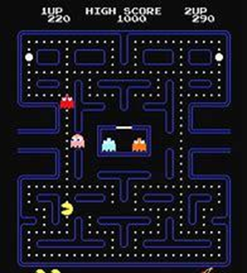

## **What I want my game to look like**



This was the order I decided I would create my game in. I chose this order since it was the best chorological way to build my game and would be very easy to notice any changes added to program when ran.

This is what I would like my game to look like on a screen

Everything circled in red would be part of the HUD. This could include things like the keys needed to escape, your health and stamina, the battery on your flash light and your ammo capacity

Footprints left by player

Footprints left by enemy

player

## **Data Flow Diagram**

Sends loaded table of high scores to be displayed

Saves players score of

how many

levels lasted

Loads scripts, assets,

resources and starts game

Quits and closes game

Gives user option to

play game or exit game

Display high scores

Load score

Save score

Exit game

Play Game

menufsdsd

User

## **My Objectives for the Game**

**(in priority order) (should be done or could be done)**

1. The game should be able to clearly showcase the end user’s art.

* Should be able to rotate around character to show all sides

1. The game should have a simple to understand user interface

* Should have a menu
* Could have a in game settings menu

1. The game should be playable with or without an objective.

* Should have smooth function player movement
* Should have implemented player collisions
* Should be able to pick up items
* Should have a functioning level system
* Could have extra features like flash light, weapons, stamina bar, hearts(lives)

1. The game should have a maze

* This maze should be randomly generated, so that every level there will be a completely different maze
* In this maze, every square should be accessible
* This maze could be interpreted as a graph so that it can be traversed for the AI

1. The game should have a fully functional enemy AI

* Shouldn’t get stuck between walls
* Should be able to follow the player (could be done by implementing a traversal algorithm)

1. The game should last as long as the player survives

* Player has 3 lives
* Should stop game as soon as player dies (or runs out of lives)
* After player finds keys and escapes a new maze should be generated.

1. After the games finishes the game should save the score and display a table of high scores

* Should save only the top 5 high scores
* If player score is high enough to enter high scores, it should ask them for their names.
* Should save the score corresponding to the input given by player

# **DESIGN**

## **Screen transitions**

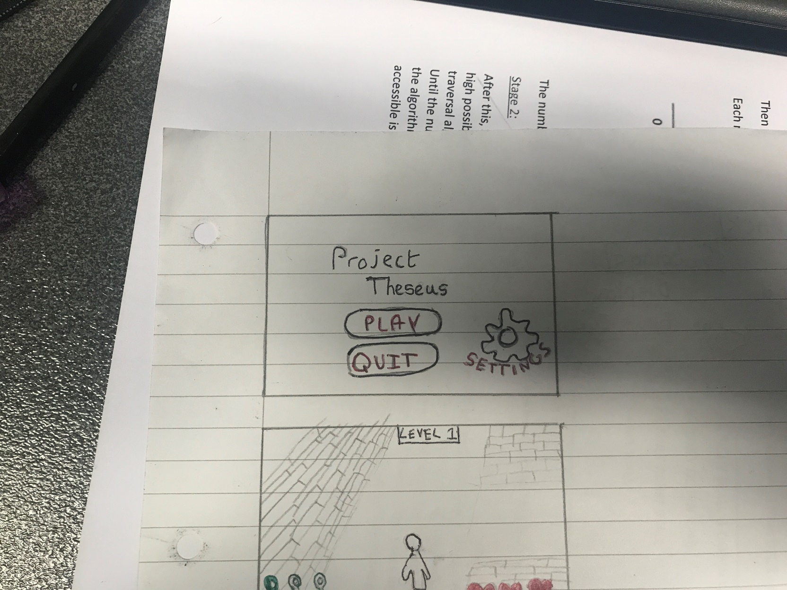**screen 1 - Menu**

This is the first screen that users will see.

The user will have 3 options:

To play the game

To open the settings menu

To quit the game

In the final system, the title screen would be more appealing and would have more pictures.

**Screen 2 Settings Menu**

In the settings menu, the user will have the option to change the sound settings, change the display settings, or go back to the main menu.

There are 4 different sound settings to choose from:

Mute - 0% volume

Low - 25% volume

Medium - 50% volume

High - 100% volume

In the display settings, the user will have to choose whether to play the game in 3rd person or birds eye view.

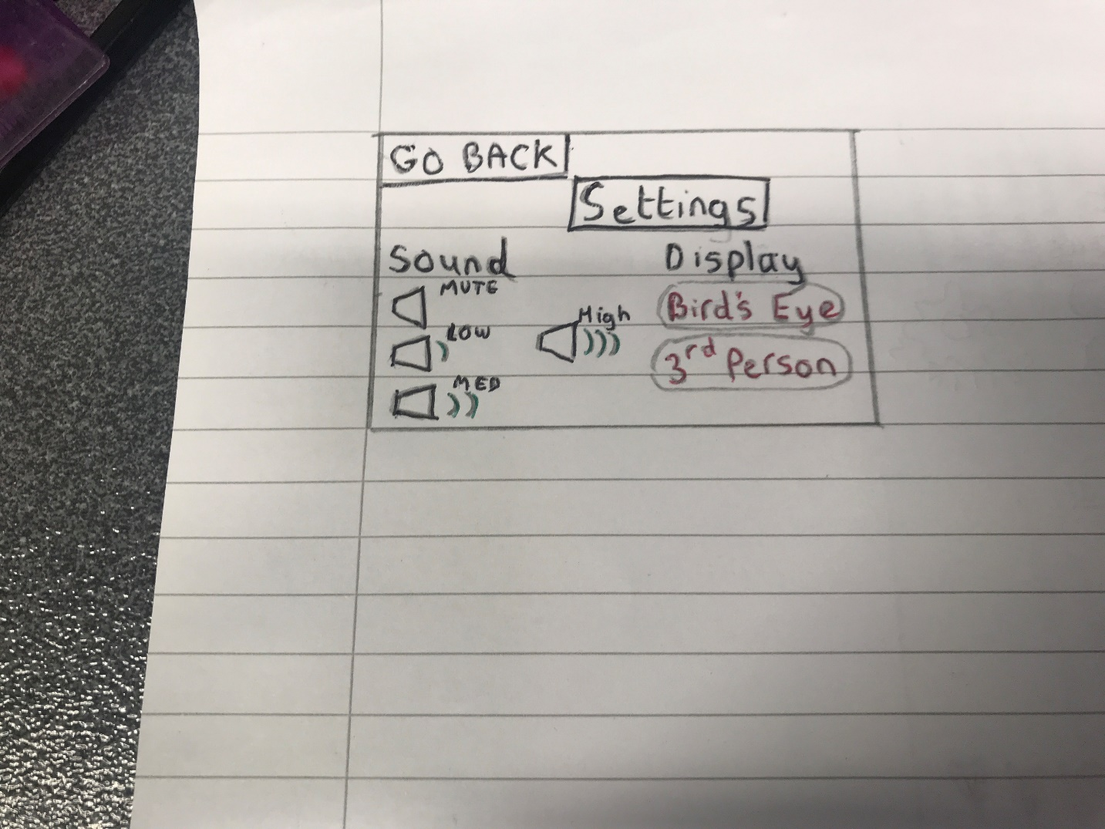

**Screen 3 – Game Screen**

After clicking play, the game screen will be loaded depending on which display setting the user picked, 3rd person or birds eye view.

In the bottom right, the players lives are displayed. There are 3 heats indicating the player has 3 lives. For every time the player comes in contact with an enemy monster they will lose a life and 1 heart will disappear. When all hearts have disappeared, the game will end

In the bottom left corner, there will be 3 outlines of keys. In order to exit the maze, the player must collect 3 keys and find the exit. For every key collected one of the outlines would get coloured in.

At the top, the level number will be displayed, so that the player always knows which level they are currently on

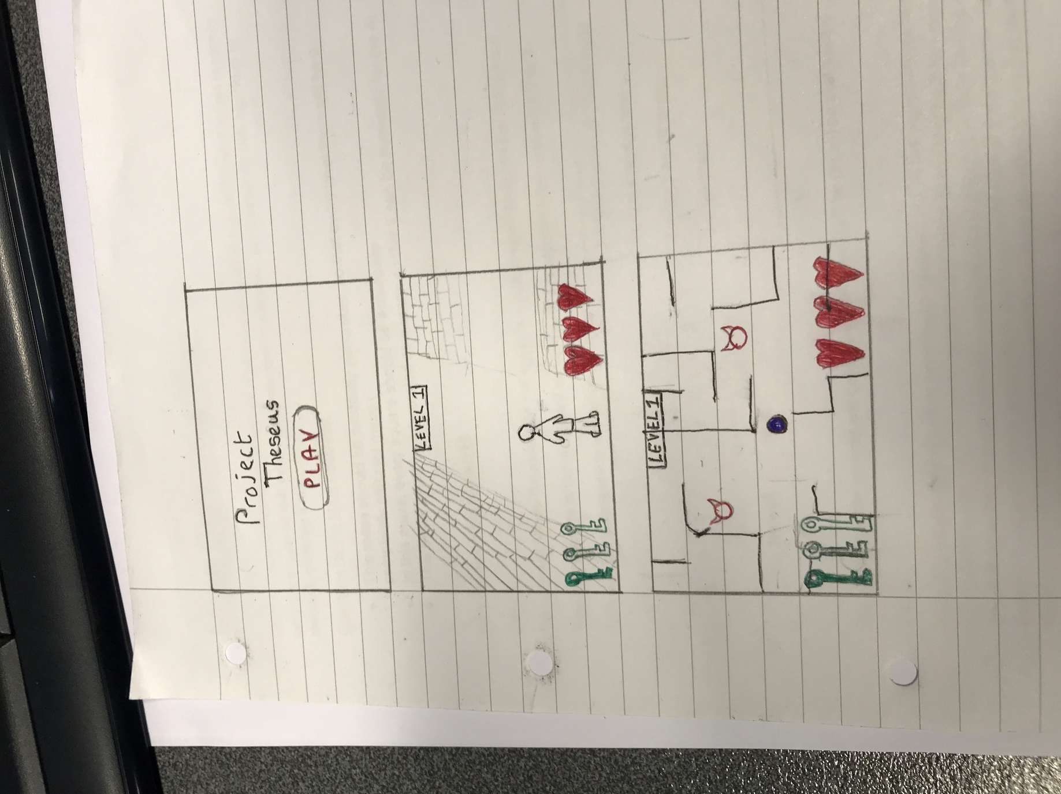

**3rd Person**

**Birds eye**

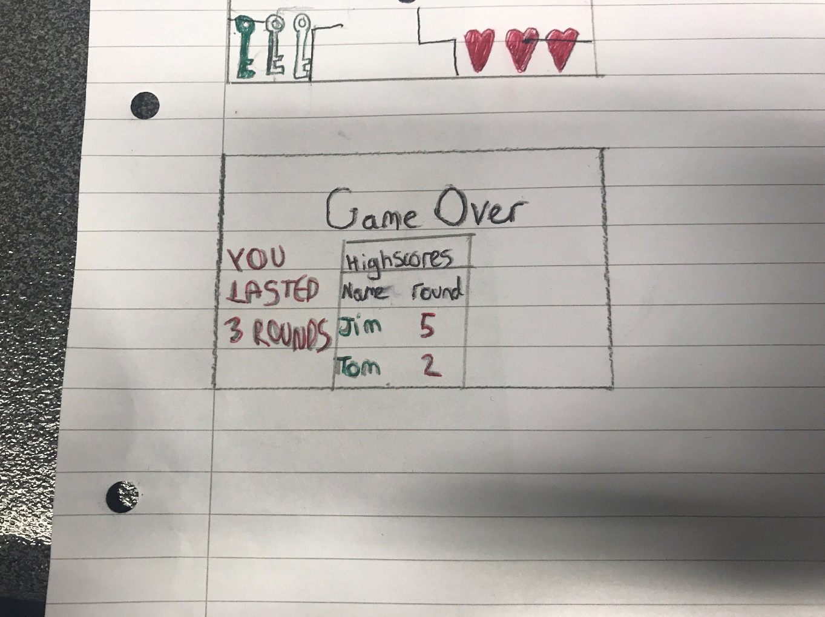**Screen 4 – Game Over/ High score screen**

After all, 3 lives have been lost. The game would finish and the game over screen would be displayed. In this screen, the game would display how many rounds the player lasted. As well as this the game would also display table of high scores which would display the names of the top

## **Maze Generator Plan**

Since my game will be revolved around a maze I would need an algorithm, which would randomly generate a maze so that every level in my game is different. so, I created my own algorithm to randomly generate a maze.

Objectives for the Maze Generator

* This maze should be randomly generated, so that every level there will be a completely different maze
* In this maze, every square should be accessible
* This maze could be interpreted as a graph so that it can be traversed for the AI

**How the algorithm will work?**

Stage 1:

The user will decide the maze size and a matrix will be created based on the user’s input

Then every square in the matrix will be filled with a random number, either 0,1,2 or 3.

Each number is assigned to a specific type of wall

0 = RIGHT WALL & DOWN WALL

1 = ONLY DOWN WALL

2 = ONLY RIGHT WALL

3 = NO WALL

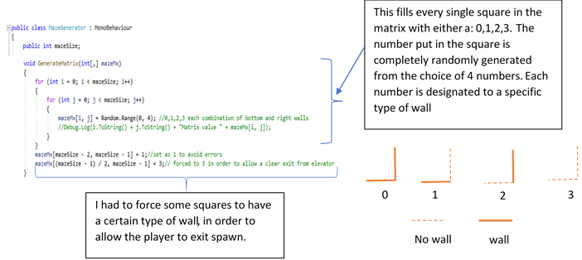

The numbers in the squares will determine which wall will be placed on that square

Stage 2:

After this, a basic maze would’ve been made. However not all the objectives are met. There is a very high possibility that every square is not accessible. So, to fix this there will be a recursive Depth First traversal algorithm. This will check how many squares are accessible from the top left of the maze. Until the number of squares accessible is not equal to the area of the maze (the users input squared) the algorithm will break walls and repeat the traversal algorithm until so that the number of squares accessible is equal to the area.

Flowchart of Maze Generator

START

**Stage 1:**

INPUT MAZE SIZE

MAZESIZE = INPUT

CREATE MATRIX SIZE MAZESIZE*MAZESIZE

FILL FIRST SQUARE WITH A RANDOM NUMBER RANGING FROM 0-3

COUNT=1

FILL NEXT SQUARE WITH A RANDOM NUMBER RANGING FROM 0-3

END

DISPLAY MAZE

COUNT=COUNT+1

NO

LOAD PREFABS OF WALLS

ASSIGNED TO EACH NUMBER

IS COUNT = MAZESIZE

YES

Example of the algorithm

This is an example of how the maze Generator Algorithm works

I decided to set the maze size input as 6, which created a 6*6 matrix.

|  |  |  |  |  |  |
| --- | --- | --- | --- | --- | --- |
|  |  |  |  |  |  |
|  |  |  |  |  |  |
|  |  |  |  |  |  |
|  |  |  |  |  |  |
|  |  |  |  |  |  |
|  |  |  |  |  |  |

The algorithm then fills every cell in the matrix with a number ranging from 0 to 3, using a random number generator (limiting the numbers generated to either 0,1,2 or 3)

|  |  |  |  |  |  |
| --- | --- | --- | --- | --- | --- |
| 3 | 0 | 1 | 3 | 0 | 2 |
| 3 | 0 | 2 | 0 | 2 | 2 |
| 2 | 3 | 1 | 0 | 2 | 1 |
| 0 | 1 | 1 | 2 | 3 | 2 |
| 2 | 3 | 3 | 1 | 0 | 0 |
| 3 | 2 | 0 | 1 | 3 | 0 |



WALLS

The algorithm then goes through every cell in the matrix, loading the wall prefab assigned to each specific number. This creates a randomly generated maze

However not all the objectives are met yet, since not every square in the maze is still not accessible

## **Explaining Maze Generator**

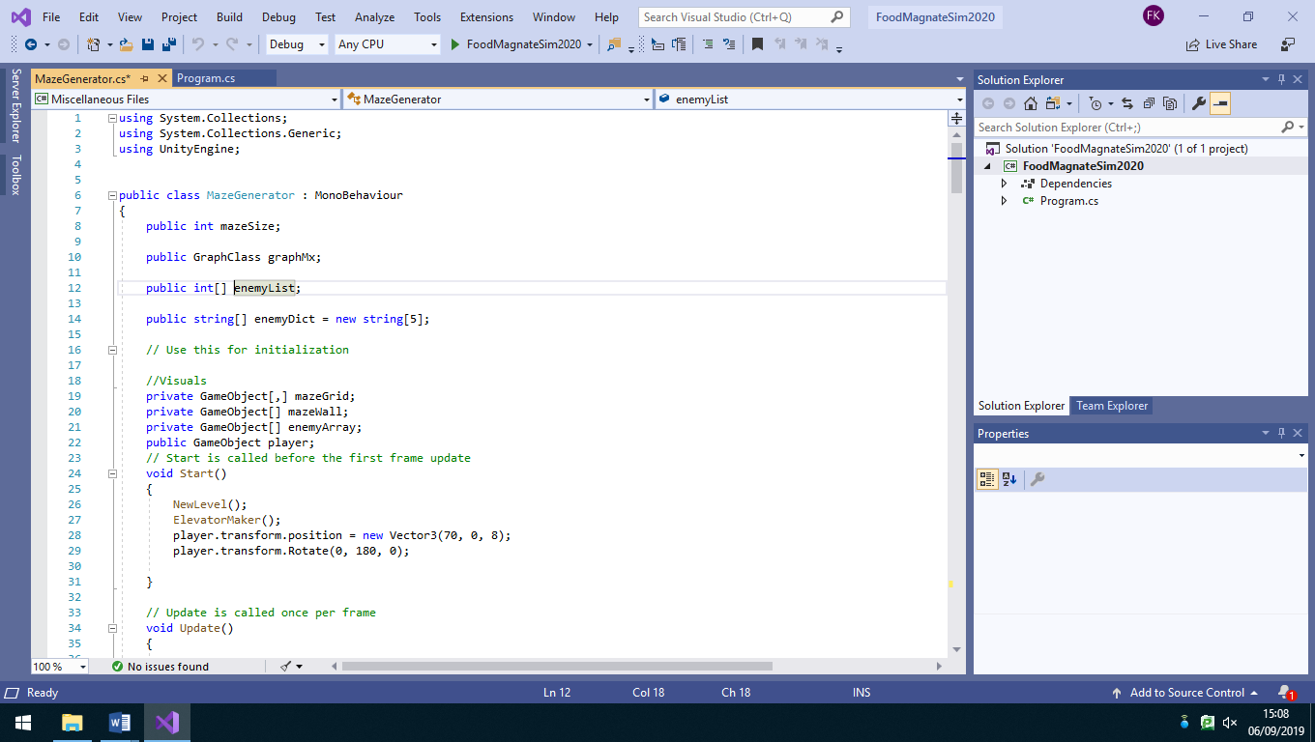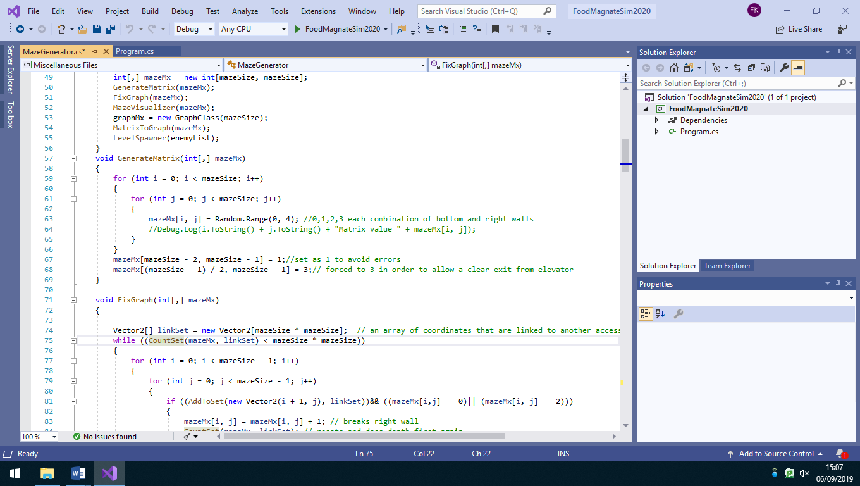

This fills every single square in the matrix with either a: 0,1,2,3. The number put in the square is completely randomly generated from the choice of 4 numbers. Each number is designated to a specific type of wall

0

1

2

3

No wall

wall

I had to force some squares to have a certain type of wall, in order to allow the player to exit spawn.

The way did this, is by creating an array, which stores all the coordinates of the squares that linked to an accessible square. I also made a depth first traversal method which starting from the top left of the matrix see’s how many squares it can go to. If the Number of squares accessible from by the depth first traversal method is equal to the area of the matrix (mazeSize * mazeSize), this would mean that the issue is fixed and every square is accessible someway.

Since every square will have a random type of wall, not every square will be accessible. In order to fix this issue, I created several different methods. The 4 methods I created to fix this issue are: FixGraph, CountSet, DepthFirst and AddToSet.

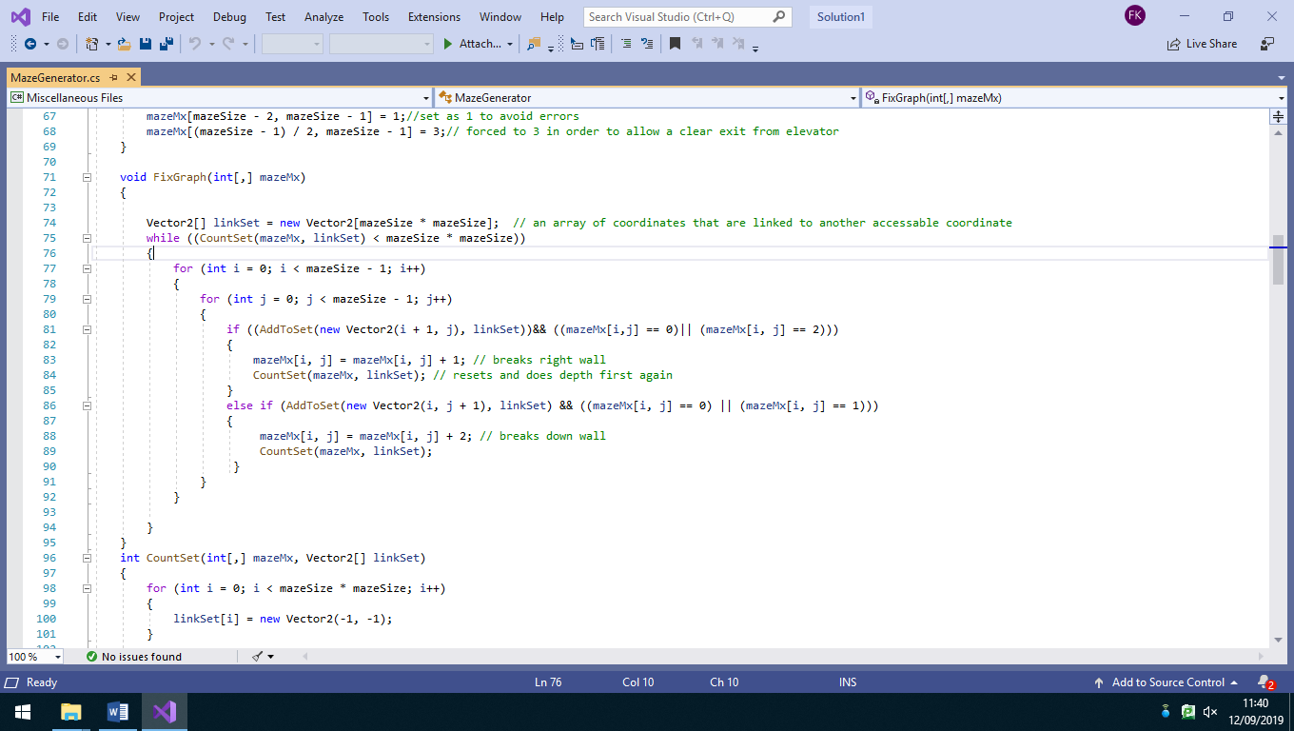

First of all, in the method FixGraph I created an empty vector 2 array called linkset which will store all the coordinates of squares that are linked to another accessible square

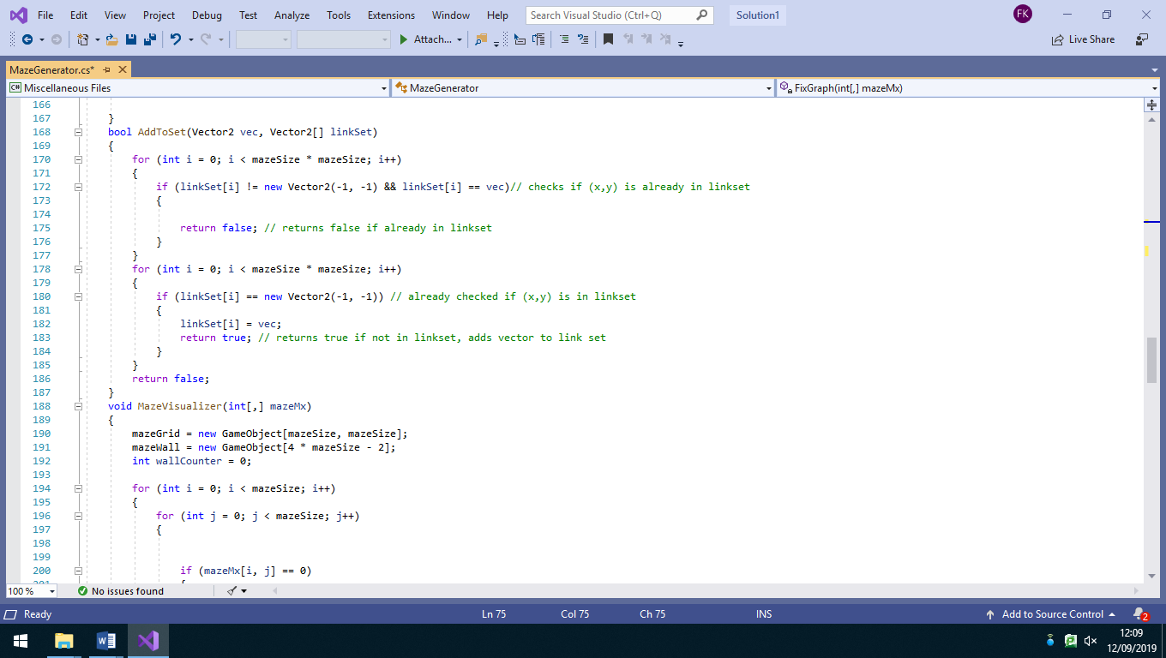

The Boolean method AddToSet checks whether the coordinate of a square is already in the linkSet array or if they need to be added. If the coordinates are not in the array AddToSet returns true indicating it needs to be added to the set. If they are in the array it returns false.

Before AddToSet is run, in the method CountSet all the elements in the vector array are set to (-1, -1), since (0, 0) is a used vector in this program

After already checking whether the coordinates are in the array, the program then checks whether the coordinates at index of the array are (-1, -1). If they are, this means that this part of the array has been untouched and the coordinates of the square can replace the (-1, -1)

After going through all the rows, while x<mazeSize the program then repeats all this for the columns while y<mazeSize. . After one y value has been traversed it then calls the recursive Depth First method with the same parameters except the y value is incremented by 1, causing the square to move down by 1 square each time.

I created a recursive function to implement depth first traversal on the maze. I called this method DepthFirst. Depth first checks all the squares accessible from the origin (0,0).

y = mazeSize -1

It starts at the origin (0,0) and first checks the square right of that. If that square is accessible (has no right wall in between) it runs the AddToSet method in order to add that coordinate to linkSet. Then it calls the recursive DepthFirst method with the same parameters except the x value is incremented by 1, causing the square to move right by 1 square each time.

x = mazeSize -1

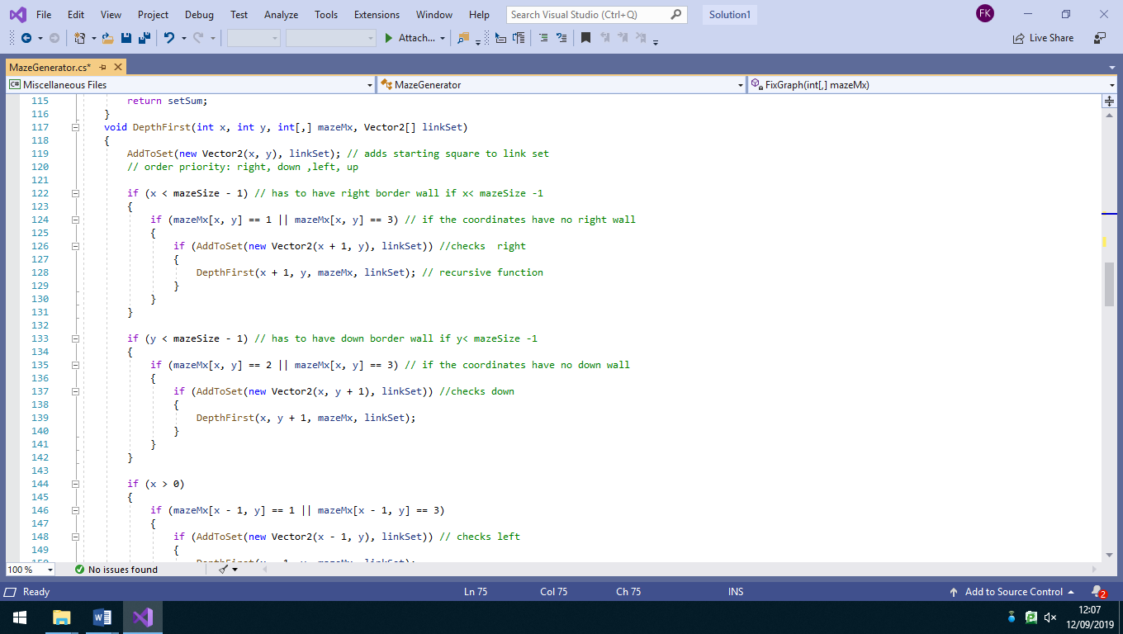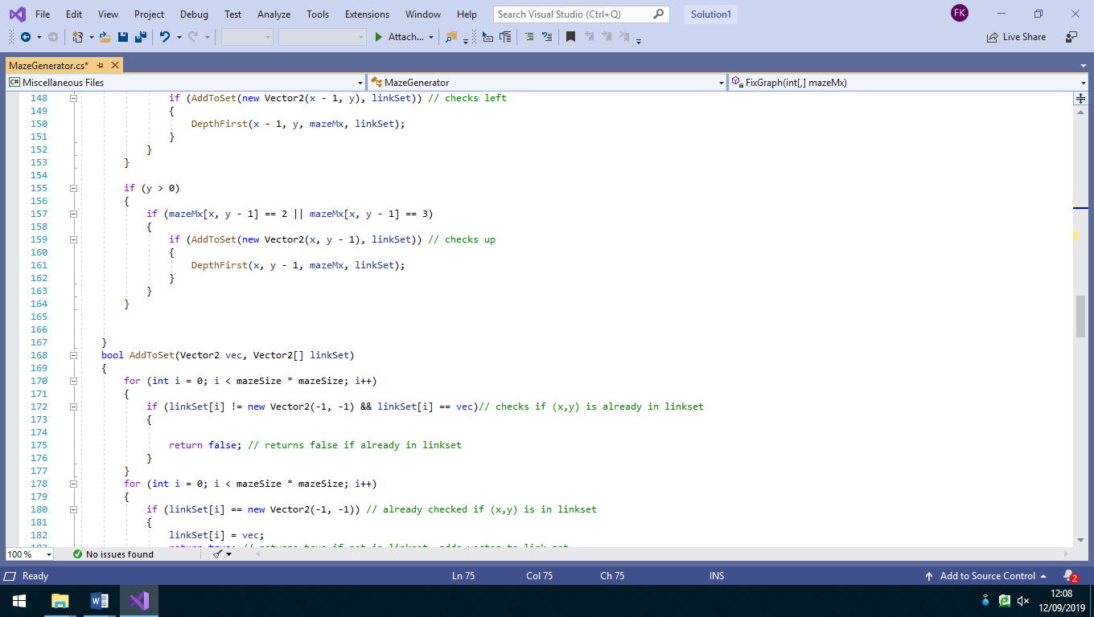

Then, for all the squares where y>0, it checks whether the square above has a down wall. If there is no down wall the square above can be accessible and the coordinates are added to linkSet. DepthFirst is called again with the same parameter except y is decreased by 1, causing the square to be 1 to the up each time

After, for all squares where x>0, it checks whether the square to the left has a right wall. If there is no wall, the square to the left can be accessible and the coordinates are added to linkSet. DepthFirst is called again with the same parameter except x is decreased by 1, causing the square to be 1 to the left each time

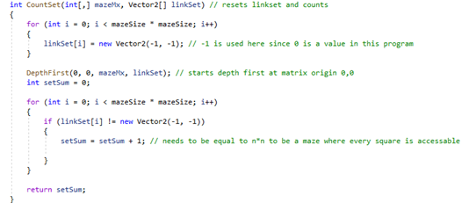

It then goes through linkSet again and if the coordinates at the index are not (-1, -1) they are accessible from the origin. For every accessible square it adds 1 to the integer variable setSum which counts the number of accessible squares. For every square to be accessible, setSum needs to be equal to the area of the matrix which would be mazeSize*mazeSize.

The method CountSet is an integer method which returns the integer variable setSum. CountSet resets linkSet so that every element in the vector array is set to (-1, -1). It then runs DepthFirst starting with the x and y coordinates set to the origin (0,0).



FixGraph is the method which starts the fix to make every square accessible. As mentioned before it starts by making an empty vector 2 array called linkSet. Then it goes through the entire matrix, where first it runs the AddToSet method to check whether the coordinate is in linkSet, if not, depending on the number it breaks a wall. corresponding to the square (if 0 or 2 it breaks right wall) (0 or 1 breaks down wall) and the runs CountSet to reset linkSet and refill it with every square accessible from origin.



MazeVisualizer is a method which actually creates the playable maze. As mentioned before that every square is assigned to a specific type of wall (either 0,1,2 or 3), MazeVisualizer loads the actual prefab for the specific wall from the Prefabs folder from the games file in unity.

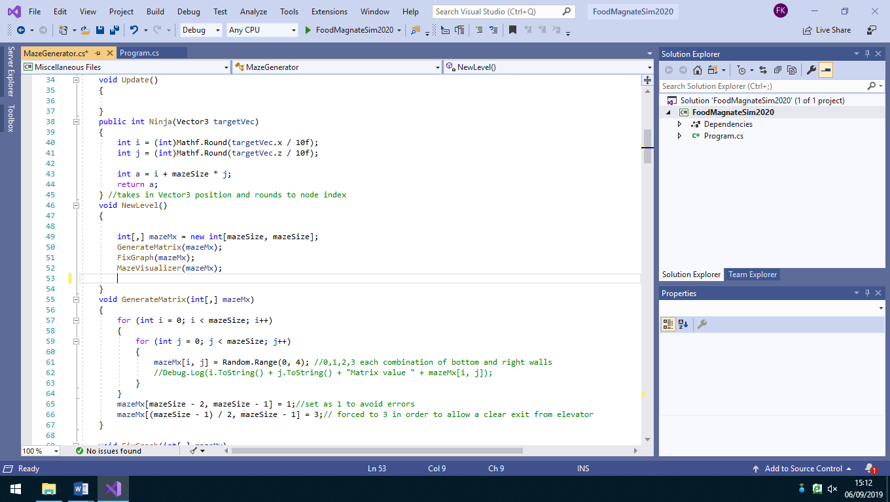

Creates a matrix (table/graph) for the base for the maze. The dimensions are mazeSize by mazeSize which is a variable which value is assigned before program runs

MazeVisualizer also creates all the border walls for the matrix.

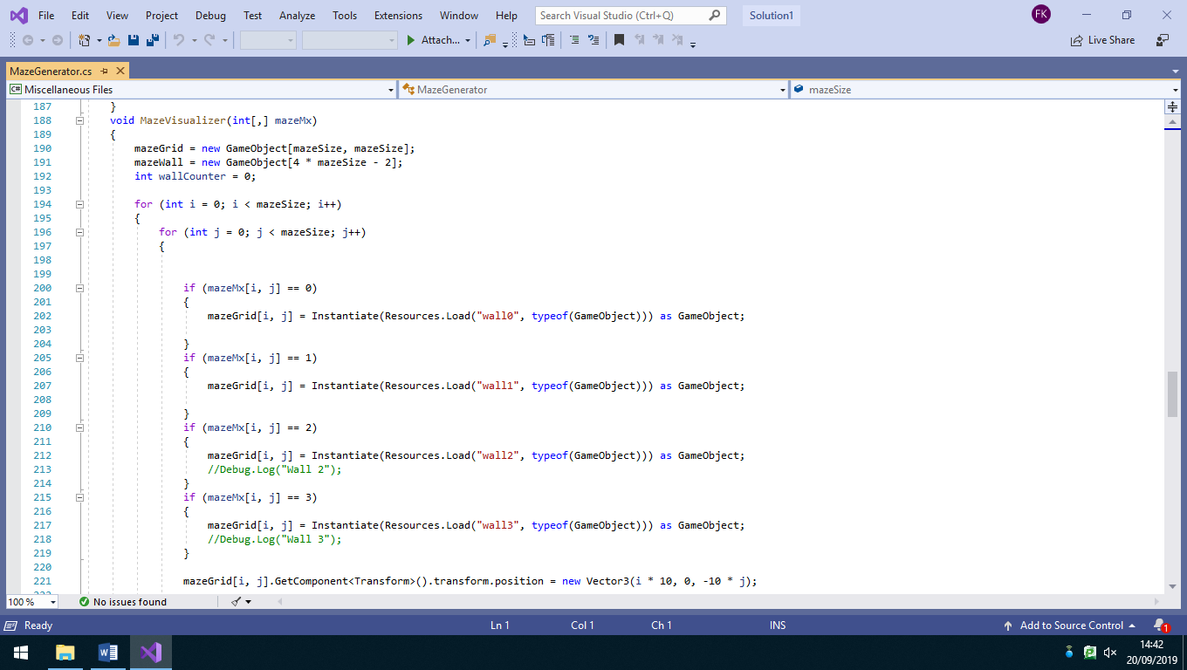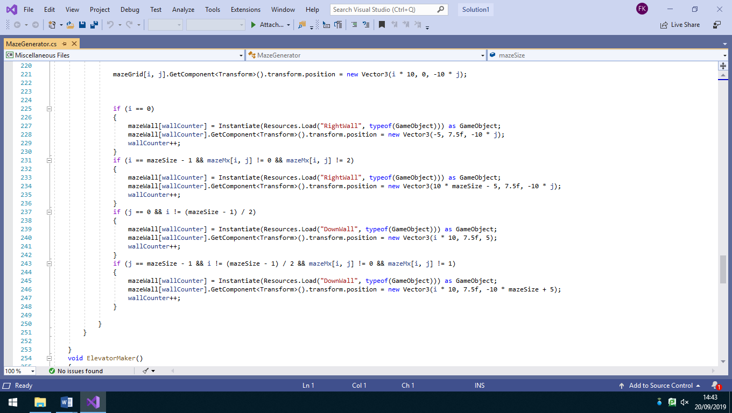

## **Maze Generator- Table of methods and Variables**

|  |  |  |  |
| --- | --- | --- | --- |
| Method Name | Variable Name | Data type | What it does? |
|  | mazeSize | int | User inputs a number of how big they want the length and width of the maze to be |
| NewLevel() |  | void | When called, creates a new maze for a new level. |
|  | mazeMx | Int, 2D array | Creates a matrix size mazeSize*mizeSize. It is the base of the maze |
| GenerateMatrix() |  | null | This fills every single square in the matrix with either a: 0,1,2,3. |
|  | i | int | Used as an index |
|  | j | int | Used as an index |
| FixGraph() |  | null | Starts the process of breaking down certain walls so that every square in the maze is accessible |
|  | linkSet | Vector 2 array | Stores the coordinates or squares that are linked to another square |
|  | i | Int | Used as an index |
|  | j | int | Used as an index |
| CountSet() |  | int | Resets the linkSet array and fills it with (-1,-1), then runs DepthFirst(). Repeats this until setSum equals mazeSize*mazeSize |
|  | i | int | Used as an index |
|  | setSum | int | Counts how many squares are accessible from the origin (0,0) |
| DepthFirst() |  | Void | checks all the squares accessible from the origin (0,0) via a traversal |
|  | x | int | Used as x coordinate in a vector |
|  | y | int | Used as y coordinate in a vector |
| AddToSet() |  | bool | checks whether the coordinates of a square are already in the linkSet array or if they need to be added |
|  | i | int | Used as an index |
|  | vec | Vector 2 | Used to check if vector coordinate has already been traversed |

## **Maze Generator - table of parameters**

|  |  |  |
| --- | --- | --- |
| Method Name | Parameters Passed | Methods called |
| NewLevel() |  | GenerateMatrix()  FixGraph() |
| GenerateMatrix() | mazeMx |  |
| FixGraph() | mazeMx | CountSet()  AddToSet() |
| CountSet() | mazeMx  linkSet | DepthFirst() |
| DepthFirst() | x (declared in CountSet)  y (declared in CountSet)  mazeMx  linkSet | AddToSet()  DepthFirst() |
| AddToSet() | Vec (declared in FixGraph() and DepthFirst() )  linkSet |  |

## **Enemy AI plan**

To make this game more interesting and complex, I decided to add an enemy ai which would follow the player around the maze. To do this I decided to convert the maze matrix into a graph which would enable the enemy to traverse it and move around. If not within a certain area, the enemy would patrol and certain area and when in range of the player, the enemy would do a breadth first traversal every frame to constantly find out where to move next and will move to that position.

**Objectives for the Enemy AI**

* Should convert the maze matrix into a graph
* Should have a range where it will not be able to follow the player
* If put the

# **Testing**

## **Public Testing**

After the development was finished, before showing my end user the final system, I allowed friends and family to play the game so that they can provide helpful feedback and also inform me of any bugs and issues with the game, which I may not have been aware of. To my advantage the game testers provided me with unbiased and helpful feedback.

Feedback

Shazaib Naeem (friend) – “The game was quite simple to understand, I liked how it got progressively more difficult, it made it more challenging and enjoyable. However, after I completed level 8 I was unable to play the game as it seemed like my character was under the map and couldn’t pick up items. So, I think that is a bug in the game but apart from that the game was good. I was able to move my character freely and its impressive how the game goes on until the player loses all lives.”

Meghan Vora (friend) – “I enjoyed playing project Theseus. I noticed how the game got harder as the levels increased, bigger mazes, more keys to collect and more monsters. I don’t know if you’re already aware but after level 8 the game becomes unplayable, so I wasn’t able to test out any after game features. I think there’s a bug which makes the player go out the maze a fall forever. As well as think I thought that I was too easy to avoid the monsters so maybe the speed of them could be increased to make it more difficult and challenging.

Ben Redfearn (friend) – “Project Theseus was quite a scary game, running into a dead end with an enemy behind gave me quite a panic, the game had elements of a well-developed game I quite enjoyed the art of the game and with the game being 3D I was able to see the arts full potential. However, I found the game to be quite difficult, after level 5 it got a bit too difficult for me. I noticed a bug where I was able to go through walls by sprinting into corners. I noticed that there was a high score table after the game finished and would like this table to be accessed at the start menu as well, I think it’d be quite irritating to only see the top scores after you’ve died so that’s one improvement which would be good.

Results from feedback

* Fix bug where the game is unplayable after level 8
* Change high score table so that it is accessible at the start as well as the end.
* Increase the enemy speed at high levels.
* Fix bug where player is able to go through walls

## **Menu Testing Table**

|  |  |  |  |  |  |
| --- | --- | --- | --- | --- | --- |
| Test Number | Test Data | Input (if needed) | Expected Outcome | Actual Outcome / evidence | Solution (if needed) |
| 1 | Main Menu |  |  |  |  |
| 1.1 |  | Click “PLAY” | Scene gets changed to game scene and game starts. |  |  |
| 1.2 |  | Click “QUIT” | Application closes |  |  |
| 1.3 |  | Click “CONTROLS” | Opens controls menu |  |  |
| 2 | Controls Menu |  | Should display the controls of the game |  |  |
| 2.1 |  | Click “BACK” | Should return back to main menu |  |  |
| 3 | Pause Menu | Press Esc key whilst in game. | Should open pause menu |  |  |
| 3.1 |  | Click “RETURN TO MENU” | Should stop the game an return to main menu. |  |  |

## **Player Movement Testing Table**

|  |  |  |  |  |  |
| --- | --- | --- | --- | --- | --- |
| Test number | Test Data  (description) | Input (if needed) | Expected Outcome | Actual Outcome / evidence | Solution (if needed) |
| 4 | Whether player movement corresponds to the right input. |  |  |  |  |
| 4.1 |  | W | Player moves forward |  |  |
| 4.2 |  | A | Player moves left |  |  |
| 4.3 |  | S | Player moves down |  |  |
| 4.4 |  | D | Player moves right |  |  |
| 4.5 |  | W & A  **simultaneously** | Player moves diagonally forward & left |  |  |
| 4.6 |  | W & D  **simultaneously** | Player moves diagonally forward & |  |  |
| 4.7 |  | Left shift  **Whilst pressing any of W, A, S, D** | Player movement speed increases |  |  |
| 5 | Whether camera moves based on mouse movement |  |  |  |  |
| 5.1 |  | Move mouse right | Camera moves to look right |  |  |
| 5.2 |  | Move mouse left | Camera moves to look left |  |  |
| 5.3 |  | Move mouse up | Camera moves to look up |  |  |
| 5.4 |  | Move mouse down | Camera moves to look down |  |  |
| 6 | Character collision |  |  |  |  |
| 6.1 |  | Walk into wall | Wall stops player from walking through |  |  |
| 6.2 |  | Sprint into wall | Wall stops player from walking through |  |  |

## **Maze Generator Testing Table**

|  |  |  |  |  |  |
| --- | --- | --- | --- | --- | --- |
| Test number | Test Data  (description) | Input (if needed) | Expected Outcome | Actual Outcome / evidence | Solution (if needed) |
| 7 | Randomly generates a maze (starting with 10) | Level 1 | Should generate a 10*10 maze |  |  |
| 7.1 | In EVERY generated maze ALL squares must be accessible. |  |  |  |  |
| 8 | After level 1 is completed the maze size should be increased by 1 for each level after 1 (capping at 21 after level) 12 |  |  |  |  |
| 8.1 |  | Level 2 | Should generate a new 11*11 maze |  |  |
| 8.2 |  | Level 3 | Should generate a new 12*12 maze |  |  |
| 8.3 |  | Level 7 | Should generate a new 16*16 maze |  |  |
| 8.4 |  | Level 12 | Should generate a new 21*21 maze |  |  |
| 8.5 |  | Level 20 | Should generate a new 21*21 maze |  |  |

## **Game Testing Table**

|  |  |  |  |  |  |
| --- | --- | --- | --- | --- | --- |
| Test number | Test Data  (description) | Input (if needed) | Expected Outcome | Actual Outcome/ Evidence | Solution (if needed) |
| 9 | The number of keys that need collecting increases by 1 every 3 levels (capping at 4 keys) |  |  |  |  |
| 9.1 |  | Level 1 | Should start spawning in 1 key |  |  |
| 9.2 |  | Level 4 | Should start spawning in 2 keys |  |  |
| 9.3 |  | Level 7 | Should start spawning in 3 keys |  |  |
| 9.4 |  | Level 10 | Should start spawning in 4 keys |  |  |
| 9.5 |  | Level 25 | Should spawn in 4 keys |  |  |
| 10 | The number of enemy AI monsters increases by 2 every 3 levels (caps at 7) |  |  |  |  |
| 10.1 |  | Level 1 | Should spawn no monsters |  |  |
| 10.2 |  | Level 4 | Should start spawning 2 monsters |  |  |
| 10.3 |  | Level 7 | Should start spawning 4 monsters |  |  |
| 10.4 |  | Level 10 | Should start spawning 6 monsters |  |  |
| 10.5 |  | Level 13 | Should start spawning 7 monsters |  |  |
| 10.6 |  | Level 30 | Should spawn 7 monsters |  |  |
| 11 | The Number of lives should decrease by 1 every time you come in contact with an enemy |  |  |  |  |
| 11.1 | Comes in contact with enemy 1st time |  | Should remove 1 life  (remaining 2/3 lives) |  |  |
| 11.2 | Comes in contact with enemy 2nd time |  | Should remove 1 life (1/3 lives remaining) |  |  |
| 11.3 | Comes in contact with enemy 3rd time |  | Should remove 1 life  (no lives remaining) should change scene to game over scene |  |  |

## **Enemy Testing Table**

|  |  |  |  |  |  |
| --- | --- | --- | --- | --- | --- |
| Test number | Test Data  (description) | Input (if needed) | Expected Outcome | Actual Outcome / evidence | Solution (if needed) |
| 12 | Enemy AI |  |  |  |  |
| 12.1 |  |  | Should patrol a random location if nit close to player |  |  |
| 12.2 |  |  | If close enough to player, enemy should track and follow player |  |  |
| 12.3 |  |  | After contact with player it should respawn at a random location. |  |  |

## **High Score Testing Table**

|  |  |  |  |  |  |
| --- | --- | --- | --- | --- | --- |
| Test number | Test Data  (description) | Input (if needed) | Expected Outcome | Actual Outcome / evidence | Solution (if needed) |
| 12 | High scores |  |  |  |  |
| 12.1 | Clicking high scores on game over menu |  | should show display the table of high scores |  |  |
| 12.2 |  |  | Table of high scores should be in order of descending scores. |  |  |
| 12.3 | Getting Name and score |  | Should set name as the user input at the start and score to level lasted. |  |  |
| 12.4 | Saving to file |  | Should save the name and score together in a json file |  |  |
| 12.5 | Max entries |  | The table should not exceed 5 entries |  |  |
| 12.6 | Replace Entries |  | After all, 5 entries are full. If the player gets a score higher than one of the high scores, it should replace the lowest entry and resort the table |  |  |

# **Evaluation**

## **Comparison with objectives**

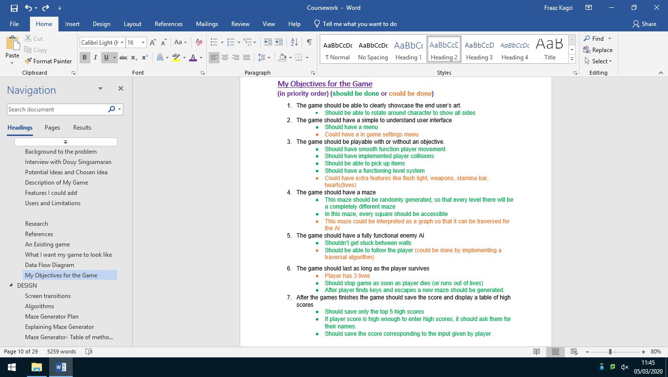

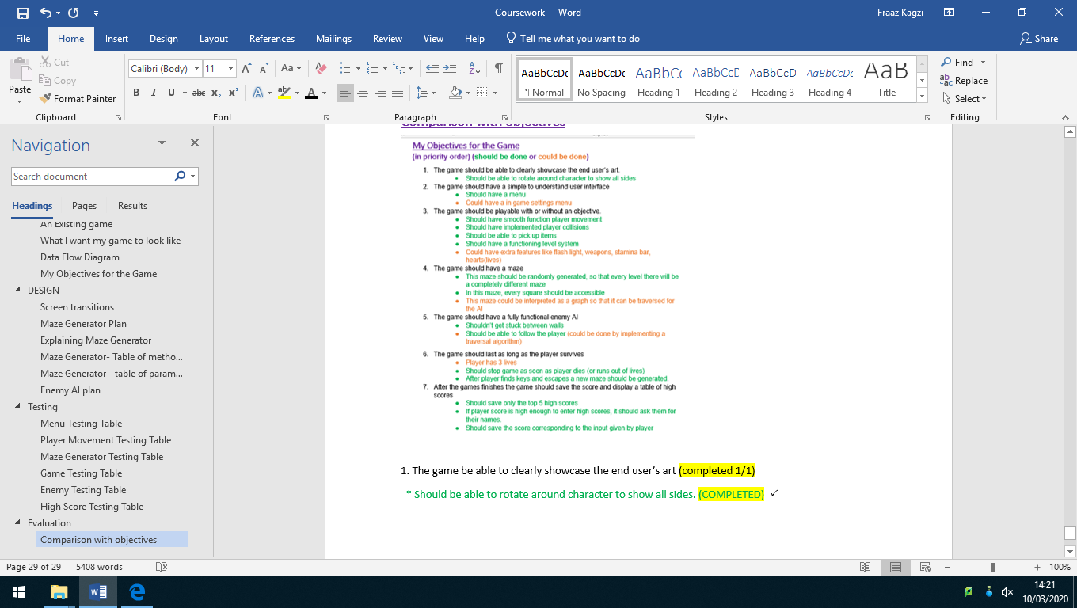















**1. The game be able to clearly showcase the end user’s art (completed 1/1)**

* Should be able to rotate around character to show all sides. (COMPLETED) 🗸

I attached a camera object to the player object so that whenever the player moves the camera will follow. As well as this I assigned the camera to correspond with mouse input. So that moving the mouse will rotate the camera around the character, showcasing all its artistic features which that end users wanted to show.

**2. The game should have a simple to understand interface (completed 2/2)**

* Should have a menu COMPLETED) 🗸

When the game loads, the player with first be greeted by a menu screen with 3 options (play, controls and quit) after receiving feedback from my public testing I decided to add the option to view the high scores from the starting menu

* Could have an in-game settings menu. COMPLETED) 🗸

Pressing esc key whilst playing the game will open the in-game settings menu, where the user will have the option to return to main menu, check the controls and quit the application. Pressing e whilst in the in-game menu will return you to the game screen. Unfortunately, I wasn’t able to make the game pause whilst in the in-game menu so pressing esc will still carry the game on meaning the playing can still lose lives even whilst in this menu.

**3. The game should be playable with or without an objective (completed 4/5)**

* Should have smooth functioning playing movement COMPLETED) 🗸

in my game I have added the basic W-A-S-D movement system to move forward – left – down – right, as well as this I added features to allow the player to sprint and have incorporated a stamina bar to go with this. Pressing left shift will make the player sprint, as well as making the stamina bar go down at the same time. Pressing left ctrl will slow but the player down but will increases the rate at which the stamina bar recharges.

*Should have implemented player collisions COMPLETED) 🗸

To my objects (such as player model, enemy model and walls) I have added in a Rigid body component built in unity. I also gave the walls box colliders and the player and enemy mesh colliders. I started to create a specific script for the player collision however I found it to be faster and more effective to use unity’s built in components.

*Should be able to pick up items COMPLETED) 🗸

There are a certain amount keys around the maze that the player needs to pick up. I have made it so that based off the number of keys that need spawning per level, that many keys will get loaded from the resources folder and each key will be transformed to a random square within the maze. I have also added a box collider to the keys and wrote a program where if the player collides with the key, it will delete the key object and remove one key from the HUD (which shows how many more are needed to collect).

*Should have a functioning level system

Per level there is a set number of keys to collect (starting with 1) and every level that is a multiple of 3 the number of keys needed is incremented by 1 (up to a max of 4 keys). E.g. level 3- 2 keys, level 6 -3 keys, level 9- 4 keys. As well as this there are enemies in the maze which the player needs to avoid. To progress on to the next level the player needs to collect the keys needed to unlock the elevator and step inside the unlocked elevator to progress on to the next level. This game should last as long as the player survives to give a more arcade element to it, however there was a bug at level 9 which dropped the player under the maze. I was unaware to fix this bug as I was unsure about what was causing it and as well as this I was restricted by time. So, because of this bug I am not counting this objective as completed.

*Could have extra features like flash light, weapons, stamina bar, hearts(lives) (PARTIALLY COMPLETED) 🗸

I was able to implement a stamina bar which is affected sprinting. Sprinting makes the bar go down, if empty the player won’t be able to sprint unless you wait until the bar charges back up or unless you hold left ctrl to charge it faster. I have also implemented lives. The player will have 3 lives, colliding with an enemy reduces one life. Losing all 3 lives will cause the game to end.

**4. The game should have a maze (completed 3/3)**

*This maze should be randomly generated so that every level there will be a completely different maze. COMPLETED) 🗸

As mentioned in the design section, there is a method of randomly generating numbers where each number (between 0-3) is assigned to a specific type of wall. This is used to create a randomly generated maze and since the maze size increases every level, no two level will have the same maze.

*In this maze every square should be accessible COMPLETED) 🗸

Also mentioned in the design section, I use a traversal algorithm to make sure that from the top left, every square is accessible in some way. If not, walls are broken to make sure that certain squares are accessible. No matter what level you are on, every square of the mazes will all be accessible.

*This maze could be interpreted as a graph so that it can be traversed for the AI COMPLETED) 🗸

I have created a graph class which would help convert the maze matrix into a graph, where each square is a node and the different ways of accessing these squares are represented by edges.

**5.The game should have a fully functioning AI (completed 2/2)**

*shouldn’t get stuck between walls COMPLETED) 🗸

One concern I had when planning the game was that since it is a maze, the enemy could get stuck between walls and would remain there until the next level. However, since the edges show which paths the enemy could take, it doesn’t get stuck between walls. When the maze is converted into a graph the graph will only show the possible routes to each square

*Should be able to follow a player (could be done by implementing a traversal algorithm). COMPLETED) 🗸

To make this system high level I didn’t want the enemy to move randomly, but instead wanted it to track and move towards the player. I implemented this by making the enemy perform breadth first traversal every frame to find out where to move next, using the players location as the target.

**6.The game should last as long as the player survives (completed 3/3)**

*Player has 3 lives COMPLETED) 🗸

The Player has 3 lives. Coming in contact with an enemy makes you lose a life.

*Should stop game as soon as player dies (or runs out of lives) COMPLETED) 🗸

As soon as all three lives have gone, the game switches over to the game over menu where you can see you high scores.

*After player finds keys and escapes a new maze should be generated. COMPLETED) 🗸

Collecting all the necessary keys and entering the end lift, creates a new maze with the maze size 1 bigger than the previous maze. It then randomly spawns in enemies and keys, then teleports the player to the start lift to start the level.

**7. After the games finishes the game should save the score and display a table of high scores (completed 3/3)**

**\***Should save only the top 5 high scores COMPLETED) 🗸

The high score table is only made for top 5 scores once it reaches it limit of 5 it will start removing lower scores and replacing them with higher scores.

*If player score is high enough to enter high scores, it should ask them for their names. COMPLETED) 🗸

In the main menu it asks the player to input their name, the game will not start until the player enters their name.

*Should save the score corresponding to the input given by player COMPLETED) 🗸

If the players score is high enough to enter the high score table it uses the name that the player inputted at the start.

## **Post-Development interview with Douy Singsamaran.**

**Have you played the game and were there any issues setting the game up?**

DS: Yes, I have played the game, the setup wasn’t too difficult all I had to do was unzip the file and run the exe file.